Team members:

Sirisha Lanka - PES1201700294

Malavikka R - PES1201700794

Kevin Arulraj - PES1201700659

# **Assignment 1**

*Problem Statement:*

Using a dataset from India’s General Elections (Lok Sabha), write a code that generates meaningful graphs with respect to the Election results.

*Dataset:*

Lok Sabha 2009 Candidates, Lok Sabha 2009 Electors,

Lok Sabha 2014 Candidates, Lok Sabha 2014 Electors

*Code:*

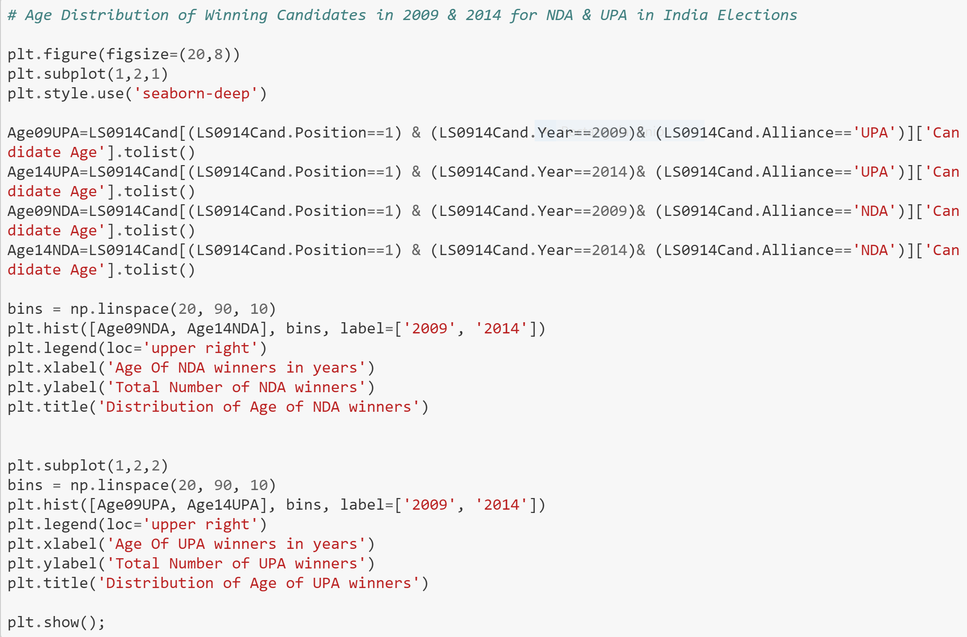

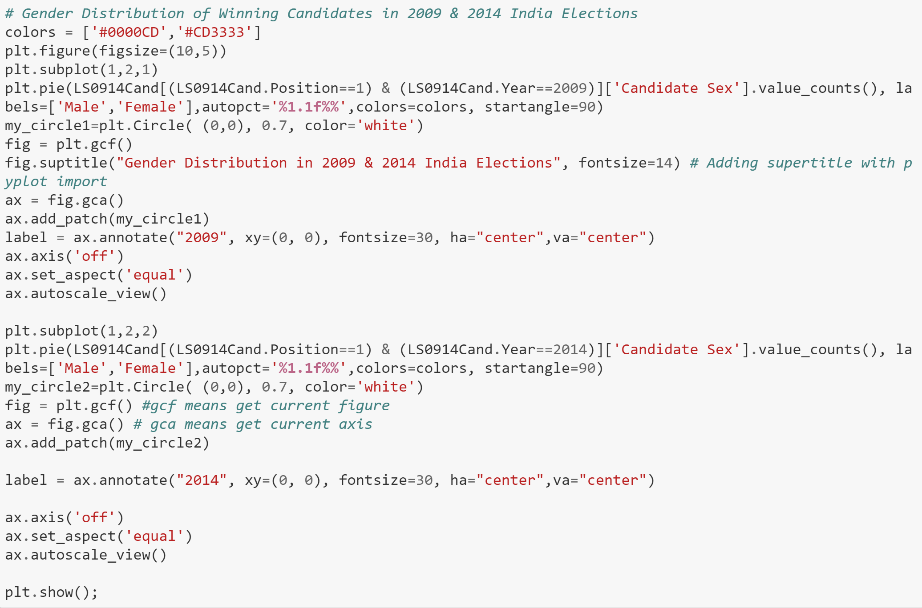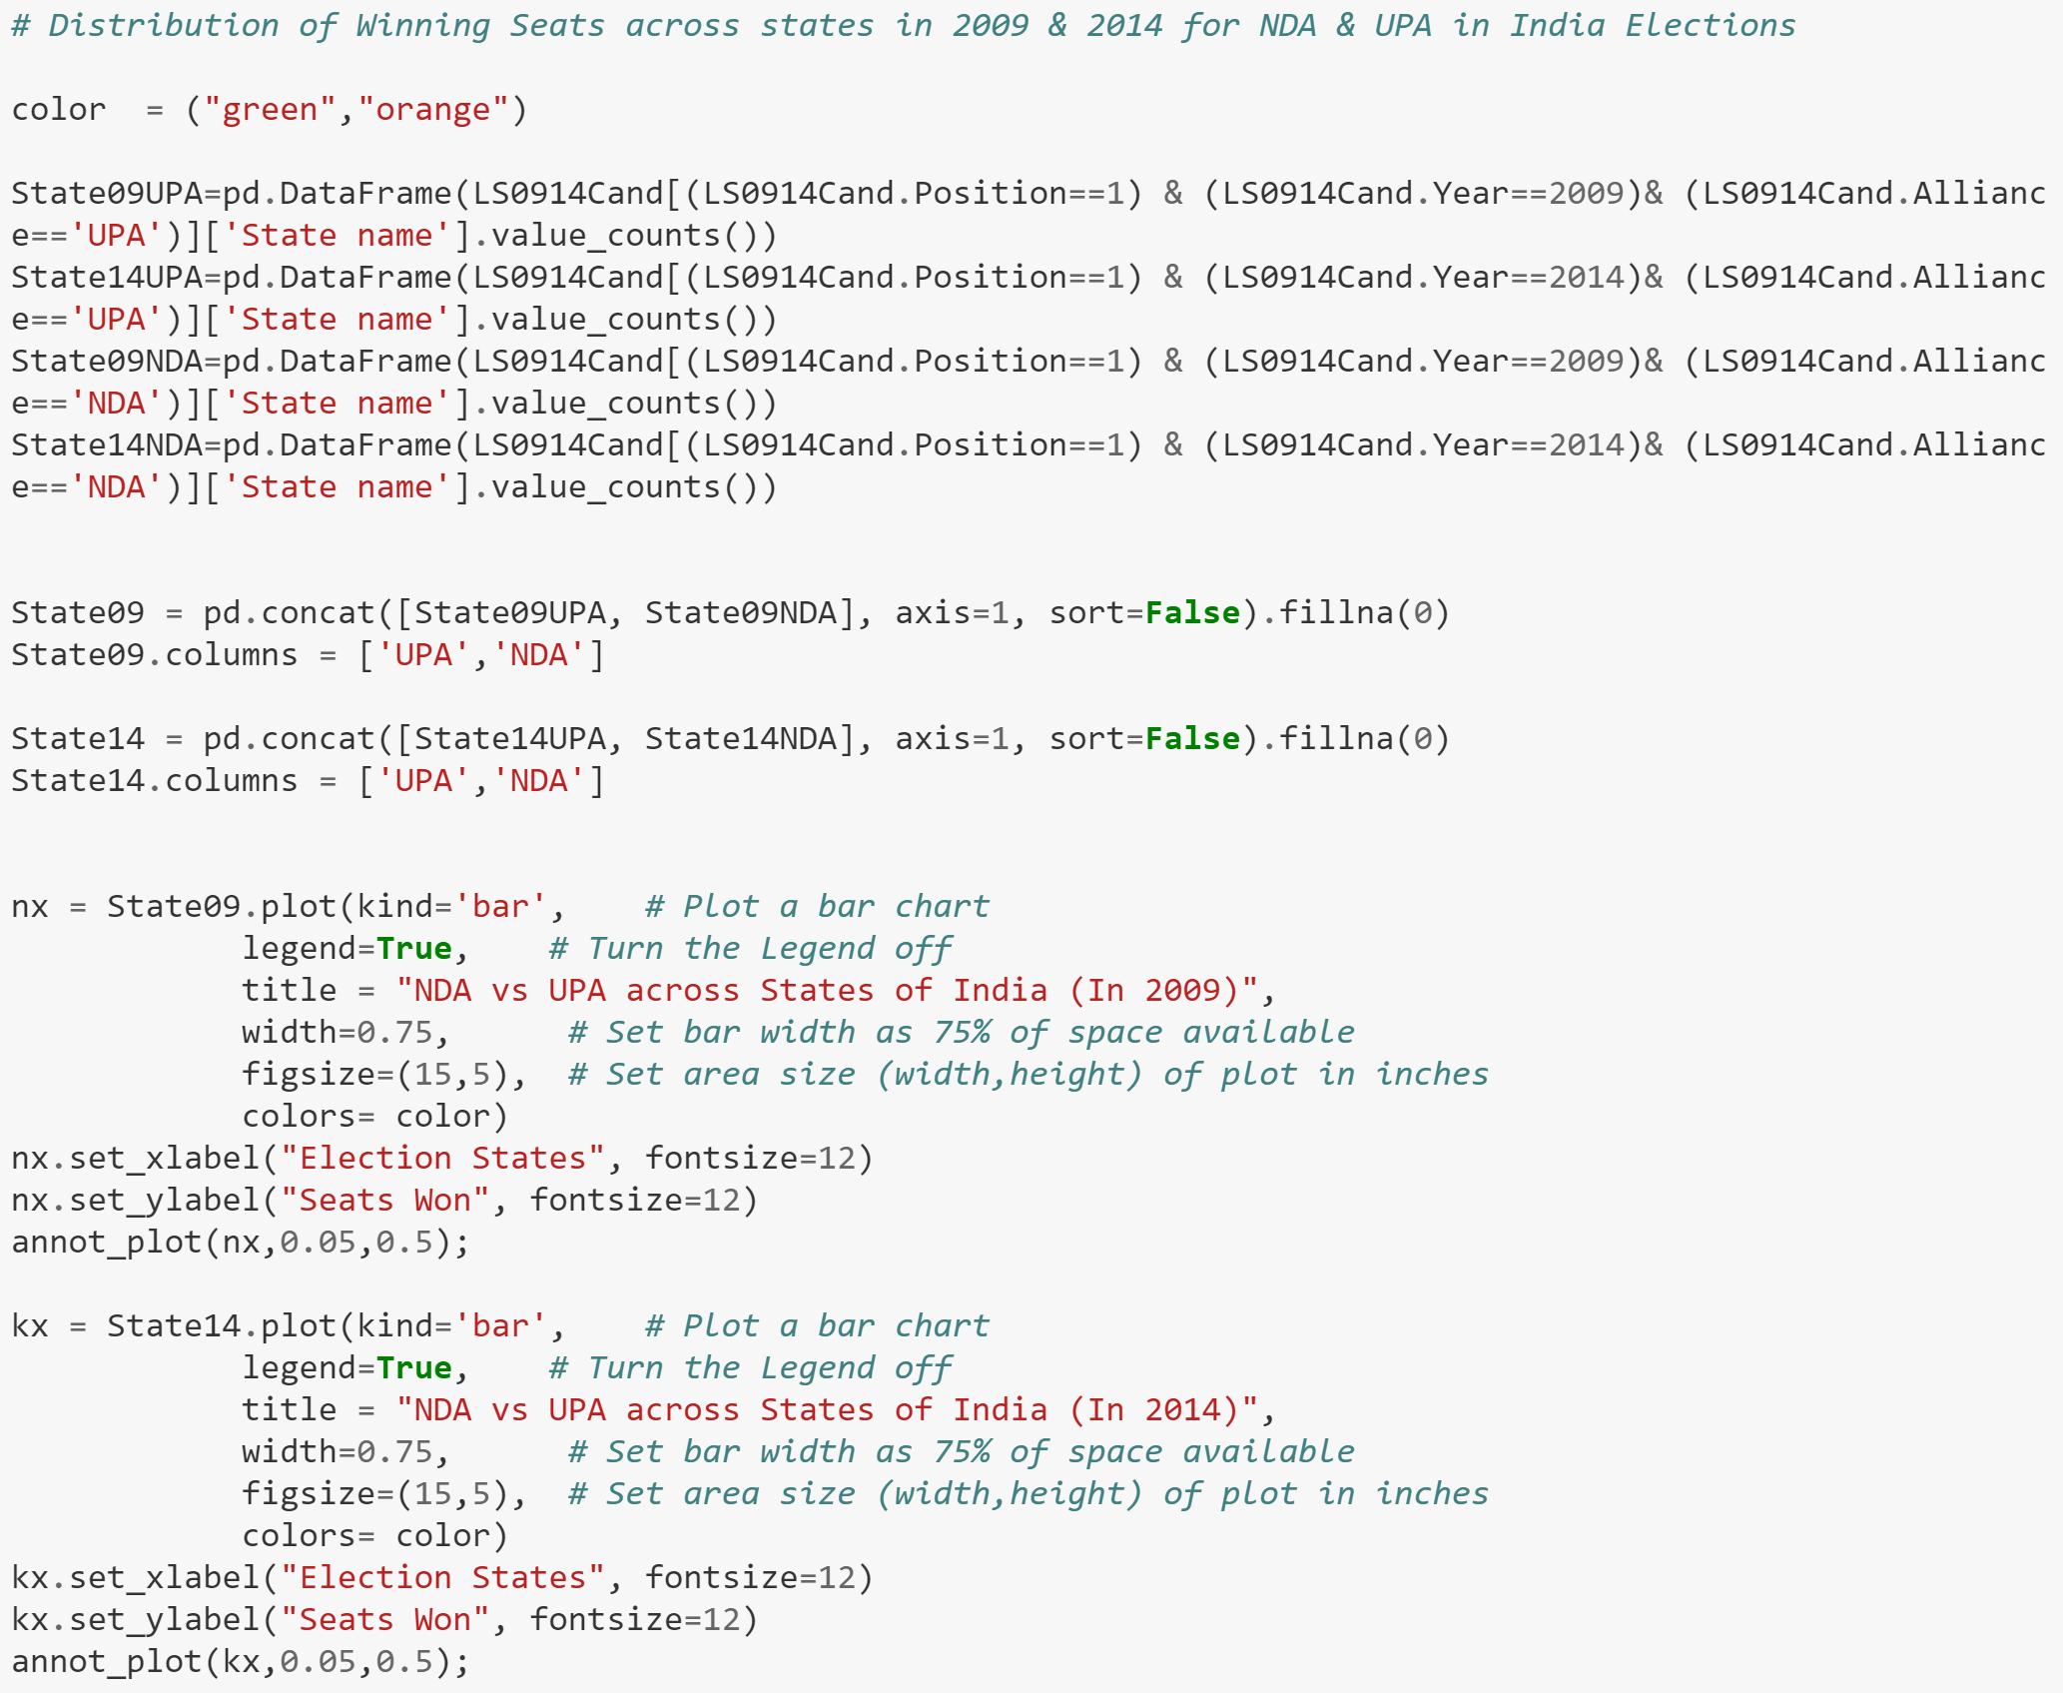

*Results:*

